General information and meet rules:
2. The pool is 50m in length x 10 lanes with Omega Quantum electronic timing, scoreboard and secondary strobe will be available; anti-wave ropes will be used.
4. All events will be swum as A & B grade based on results on the day.
5. Age groups are 9yrs, 10yrs, 11yrs, 12yrs, 13yrs, 14yrs, 15yrs&over. Competition ages will be as 10 th December 2022.
6. All events will be heat declared winners for A & B Grade. Heats will be arranged according to submitted times.
9. All entries will be dealt with on a first come first serve basis.
10. Any entry errors must be reported to the organiser as soon as possible, prior to the meet, to allow time to amend the programme and start lists on the day.
11. Withdrawals will be accepted by e-mail until Friday 9 th December at 12 noon. No withdrawals will be accepted on the day.
13. Late entries will not be accepted unless on a lane-fill basis and at the organisers discretion.
15. Awards will be presented to the first 6 swimmers in each age group, in each grade
16. Presentations will not be made. Competitors who have won an award must report to the medals table when called by the announcer.
19. The referee’s decision is final.
20. Any restrictions relating to Covid-19 will be applied, as defined by Swim England guidance and UK Government rules at the time of the gala.
21. No outdoor shoes must be worn on poolside; footwear must be worn outside the pool area.
22. No glass containers are permitted on the poolside.
23. All attendees are advised not to leave clothes or equipment lying around as neither the promoters or Ponds Forge Management can accept liability for any loss or damage. Any lost property should be taken to the announcers table.
24. The promoters reserve the right to refuse admission to any competitor or spectator.
25. When entering this event, you agree that we may collect and publish personal information as part of the entry to and results of the event. We may pass such information to the Governing Body or Affiliated organisations for the purpose of membership and qualification checking. Following the event your personal information will be used for publishing results either for the event alone or combined with or compared to other events (British Rankings). The published results may include (but not limited to) Name, Club Membership, Race, Times, Age, Category
26. Any matter not covered in the above will be at the discretion of the organisers. Any queries should be directed to the club Secretary (Jo Ingram) on gala@bobsc.co.uk

Schedule of Events
Session 1 – Warm up 8am Session 2 – Warm up TBC
Start Time – 9am Start time - TBC Event
101 – Girls 200m IM Event 201 – Boys 200m IM
102 – Boys 100m Backstroke 202 – Girls 50m Backstroke
103 – Girls 100m Butterfly 203 – Boys 50m Breaststroke
104 – Boys 100m Breaststroke 204 – Girls 50m Butterfly
105 – Girls 100m Backstroke 205 – Boys 50m Backstroke
106 – Boys 50m Butterfly 206 – Girls 100m Breaststroke
107 – Girls 50m Breaststroke 207 – Boys 100m Butterfly
108 – Boys 50m Freestyle 208 – Girls 100m Freestyle
109 – Girls 50m Freestyle 209 – Boys 100m Freestyle

Grade A Cut-off times

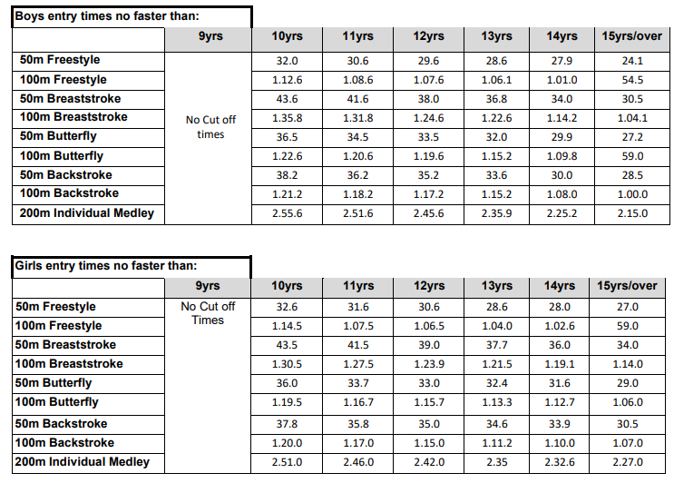

B Grade cut off times
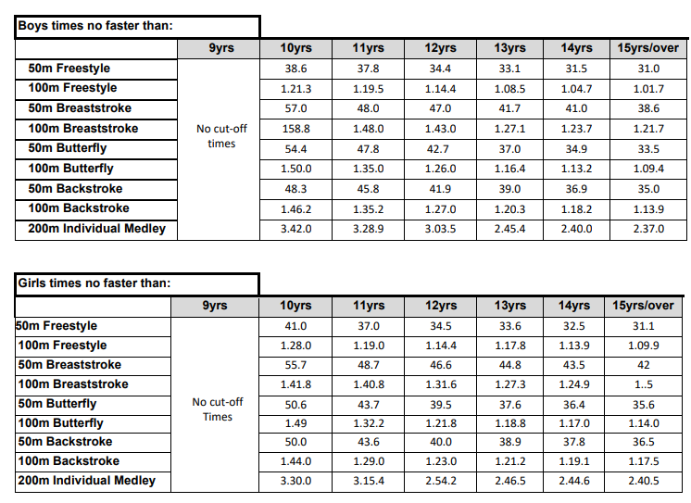

Long Course Pool (converted times will be accepted)
Please note there is no additional tolerance permitted on the above times. If the time swum on the day is faster on the day than B grade cut-off, the swimmer will automatically be classed as A grade.
No entries will be accepted with times faster than the A grade cut off times.
No awards for places 1-6 will be made to swimmers who swim faster than the A grade cut-off times, they will however receive a speeding medal

BOBSC Christmas Sprint : Closing Date for Entries 6th October 2022 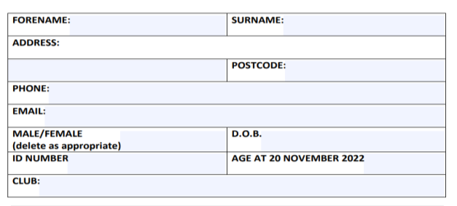
SE Number | Name | Date of Birth | Age at 10th December 2022
Email address |  | Phone Number | Male / Female

Event | Entry Time | Event | Entry Time
101 – Girls 200m IM Event |  | 201 – Boys 200m IM
102 – Boys 100m Backstroke |  | 202 – Girls 50m Backstroke
103 – Girls 100m Butterfly |  | 203 – Boys 50m Breaststroke
104 – Boys 100m Breaststroke |  | 204 – Girls 50m Butterfly
105 – Girls 100m Backstroke |  | 205 – Boys 50m Backstroke
106 – Boys 50m Butterfly |  | 206 – Girls 100m Breaststroke
107 – Girls 50m Breaststroke |  | 207 – Boys 100m Butterfly
108 – Boys 50m Freestyle |  | 208 – Girls 100m Freestyle
109 – Girls 50m Freestyle |  | 209 – Boys 100m Freestyle

ENTRIES
No of entries ……………………….@ £6.50 per entry £………………….
Contribution to Coaches Pass / Expenses £2.00

TOTAL £………………….

Payment by Cheque / Standing Order Payment (date of transfer______________)

