Blackpool Lights 2022
Palatine Leisure Centre 207 St. Anne’s Road Blackpool FY4 2AP
19/20 November 2022
The competition is open to all swimmers who are at least 9 years old on the final day of the meet and who are registered competitive members of Swim England (Club Compete)
Age Groups The Age Groups will be 9, 10, 11, 12, 13,and 14/over. Age as at midnight on 20 November 2022. Pool
The competition shall be held in an 8 lane 25m pool with anti wave lane ropes. Electronic timing shall be in operation. Events and Entries Events are 50m, 100m, 200m all strokes, 100m.I.M. and 200m I.M. NB: 200m IM & 200m Fly 10 yrs + over
Entries shall be accepted on a first come first served basis. ORCA closing date is END OF TRAINING ON MONDAY 10th OCTOBER
Accepted entries will be posted on the club website after the meet has closed. A refund will be given to clubs whose entry is denied where this condition has been exercised.
Fees and Payment The entry fee shall be £5.75 per event plus £2 per swimmer to contribute to Coaches Passes and expenses.
Payment for entries must be made by a Bank Transfer to ORCA SC (please note the date of payment on the Entry form) or by Cheque made out to ORCA SC
Spectator entry shall be by colour coded wristbands. Entry fees £5 per day, £3 per session. The promoter reserves the right to refuse admission to any spectator, coach, or swimmer.
PROGRAMME OF EVENTS
SESSION 1 SESSION 2
Saturday 19 November Saturday 19 November
Event 101 Boys 100m IM Event 201 Girls 200m IM
Event 102 Girls 50m Butterfly Event 202 Boys 50m Breaststroke Event
103 Boys 50m Backstroke Event 203 Girls 50m Freestyle
Event 104 Girls 200m Breaststroke Event 204 Boys 200m Freestyle
Event 105 Boys 100m Breaststroke Event 205 Girls 200m Backstroke
Event 106 Girls 100m Freestyle Event 206 Boys 100m Backstroke
Event 107 Boys 200m Butterfly Event 207 Girls 100m Butterfly

SESSION 3 SESSION 4
Sunday 20 November Sunday 20 November
Event 301 Girls 100m IM Event 401 Boys 200m IM
Event 302 Boys 50m Butterfly Event 402 Girls 50m Breaststroke
Event 303 Girls 50m Backstroke Event 403 Boys 50m Freestyle
Event 304 Boys 200m Breaststroke Event 404 Girls 200m Freestyle
Event 305 Girls 100m Breaststroke Event 405 Boys 200m Backstroke
Event 306 Boys 100m Freestyle Event 406 Girls 100m Backstroke
Event 307 Girls 200m Butterfly Event 407 Boys 100m Butterfly

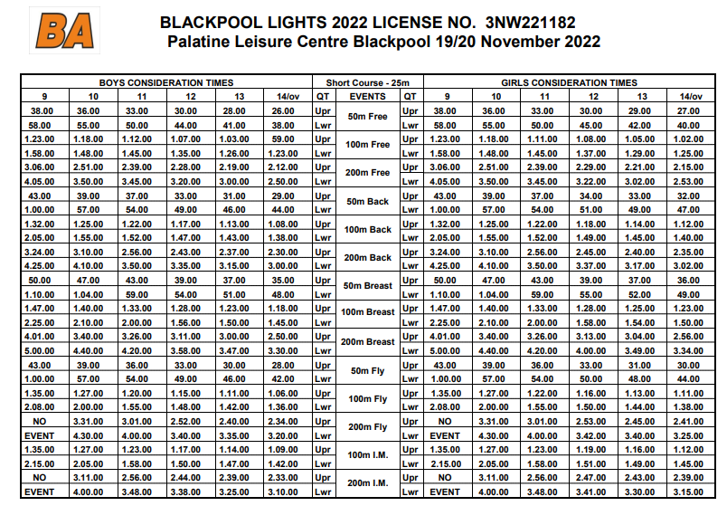

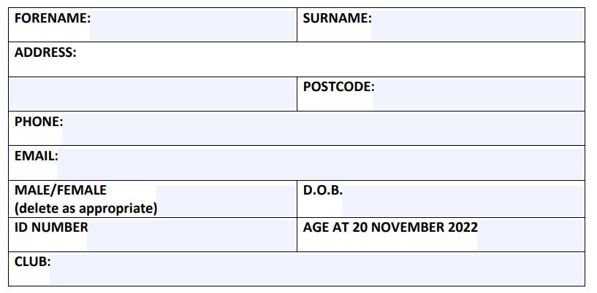
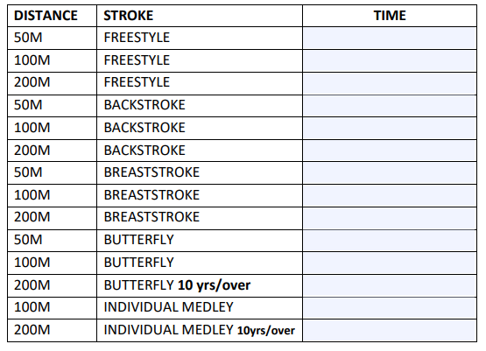

Number of Entries ___________ at £5.75 per Entry : Sub Total £_______________
Contribution to Coaches Pass / expenses £2.00
TOTAL £_______________
Payment Made by Cheque / Bank Transfer on Date _______________

